**TASK 1: CLONING AND FORKING**

**1. Cloning a Repository**

1. Choose a public GitHub repository of interest.

**- Repository URL: `https://github.com/ditdot-dev/vue-flow-form’**

2. Clone the repository to your local machine:

**git clone https://github.com/ditdot-dev/vue-flow-form**

3. Explore the repository's structure, files, and history:

- Navigate into the repository:

**cd public**

- List the files:

**Ls**

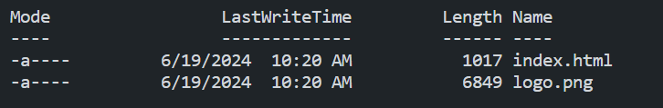

- View the commit history:

git log

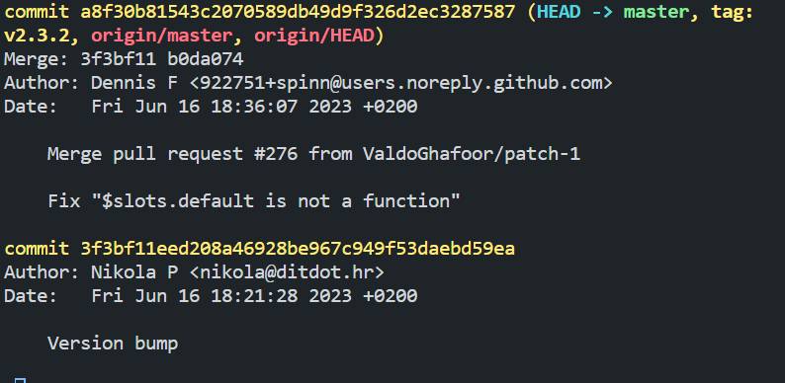

**2. Forking a Repository**

**1. Fork the repository**:

- Go to the repository page on GitHub (`**https://github.com/ditdot-dev/vue-flow-form’**)

- Click the "Fork" button in the top-right corner.

**2. Clone the forked repository to your local machine:**

- Get the URL of your forked repository, e.g. **`https://github.com/faithckip/vue-flow-form.git`.**

git clone https://github.com/faithckip/vue-flow-form.git

**Task 2: Managing Branches**

**3. Creating and Switching Branches**

**1. Create a new branch:**

git checkout -b feature-update

🡪 Switched to a new branch 'feature-update'

**2. Verify you are on the new branch:**

git branch

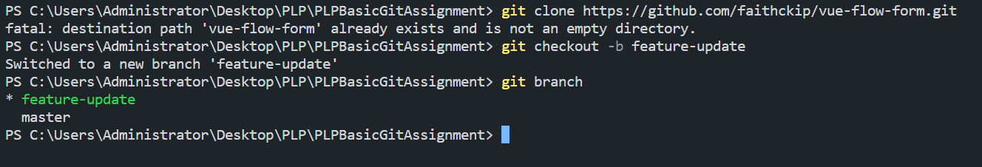

**4. Making Changes and Committing**

1. Make changes to a file or add a new file:

create a new file, e.g., `newfile.txt`.

2. Stage the changes:

git add newfile.txt

3. Commit the changes:

git commit -m "Added newfile.txt"

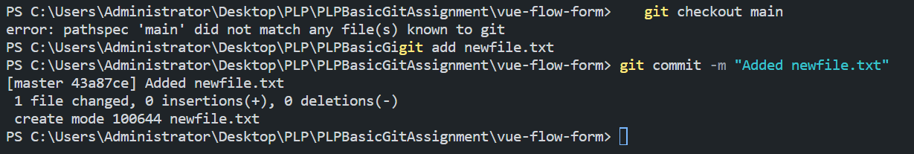

**5. Merging Changes**

1. Switch back to the main branch:

**git checkout main**

2. Merge the changes from `feature-update` into `main`:

**git merge feature-update**

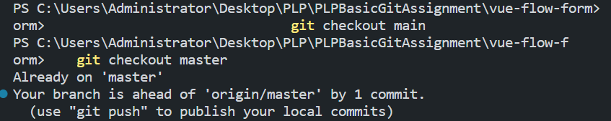

Task 3: Handling Conflicts

**6. Creating Conflicts**

1. Make changes to the same file (e.g., `README.md`) in the forked repository on GitHub.

2. Commit the changes directly on GitHub.

**7. Resolving Conflicts**

**1. Pull the changes from the remote repository:**

git pull origin main

**2. Create a new branch to resolve the conflict:**

git checkout -b resolve-conflict

**3. Resolve the conflict manually by editing the file.**

**4. Stage the resolved file:**

git add README.md

**5. Commit the changes:**

git commit -m "Resolved merge conflict in README.md"

**6. Switch back to `main` and merge the conflict-resolving branch**:

git checkout main

git merge resolve-conflict

**Task 4: GitHub Pages**

8. Enabling GitHub Pages

1. Create a simple HTML file (e.g., `index.html`):

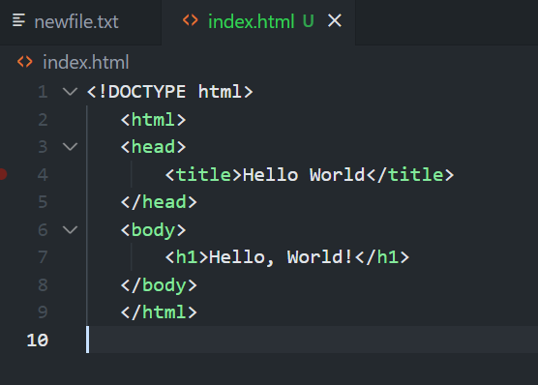

2. Add and commit the `index.html` file:

**git add index.html**

**git commit -m "Added index.html for GitHub Pages"**

3. Push the changes to GitHub:

**git push origin master**

4. Enable GitHub Pages:

- Go to the repository settings on GitHub.

- Scroll down to the "GitHub Pages" section.

- Select the source branch as `main` and save.

**9. Accessing the Published Page**

**1. Visit the GitHub Pages URL, which is typically:**

`**https://github.com/ditdot-dev/vue-flow-form’**

2. Verify that the HTML file is accessible online.

**Task 5: Open Source Exploration**

**10. Exploring Open Source Projects**

1. Search for an open-source project on GitHub related to your interests.

- Use the GitHub search functionality and filters.

2. Explore the project's documentation, issues, and contribution guidelines:

- Read the `README.md`, `CONTRIBUTING.md`, and other documentation files.

- Browse through the open issues to understand the project's needs and problems.

**11. Opening an Issue**

1. Open a new issue in the chosen Vue-flow-form project:

- Go to the "Issues" tab of the repository.

- Click on "New issue".

- Provide a descriptive title and detailed description, suggesting an improvement, reporting a bug, or asking for clarification.

- Submit the issue.